**DAILY ONLINE ACTIVITIES SUMMARY**

|  |  |  |  |  |  |  |  |
| --- | --- | --- | --- | --- | --- | --- | --- |
| **Date:** | **05-06-2020** | | | | **Name:** | **Gudugunti Anirudh** | |
| **Sem & Sec** | **IV - A** | | | | **USN:** | **4AL18CS023** | |
| **Online Test Summary** | | | | | | | |
| **Subject** | | **N/A** | | | | | |
| **Max. Marks** | | **N/A** | | **Score** | | **N/A** | |
| **Certification Course Summary** | | | | | | | |
| **Course** | **Basics of data structures and algorithms in c++** | | | | | | |
| **Certificate Provider** | | | **Udemy** | **Duration** | | | **2.5hrs** |
| **Coding Challenges** | | | | | | | |
| **Problem Statement:** 1: Program to find how many of the input numbers can be written as powers of 2.  2.You are given an array of n numbers and q queries. For each query you have to print the floor of the expected value(mean) of the subarray from L to R. | | | | | | | |
| **Status: completed** | | | | | | | |
| **Uploaded the report in Github** | | | | **yes** | | | |
| **If yes Repository name** | | | | **https://github.com/alvas-education-foundation/anirudh_gudugunti/tree/master/daily_progress** | | | |
| **Uploaded the report in slack** | | | | **yes** | | | |

ONLINE TEST DETAILS: N/A

Certification Course Details:

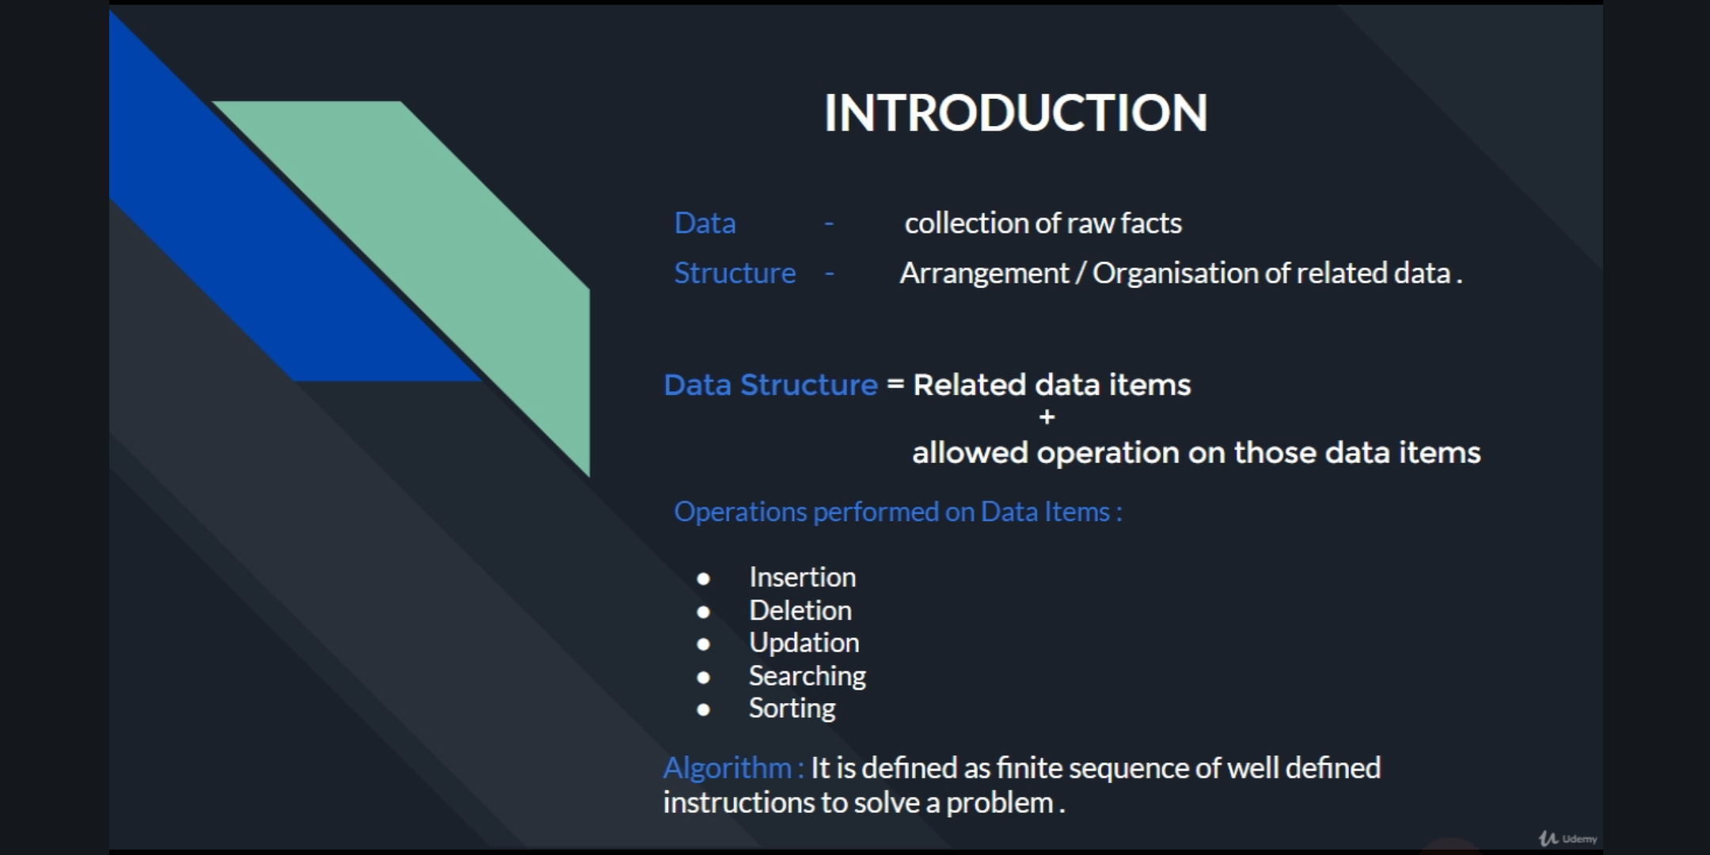

1. Introduction and definition of Data structures.

2. Operations performed on Data structures.

3. Definition of Algorithms.

CODING CHALLENGES DETAILS:

Problem 1: (using python) Program to find how many of the input numbers can be written as powers of 2.

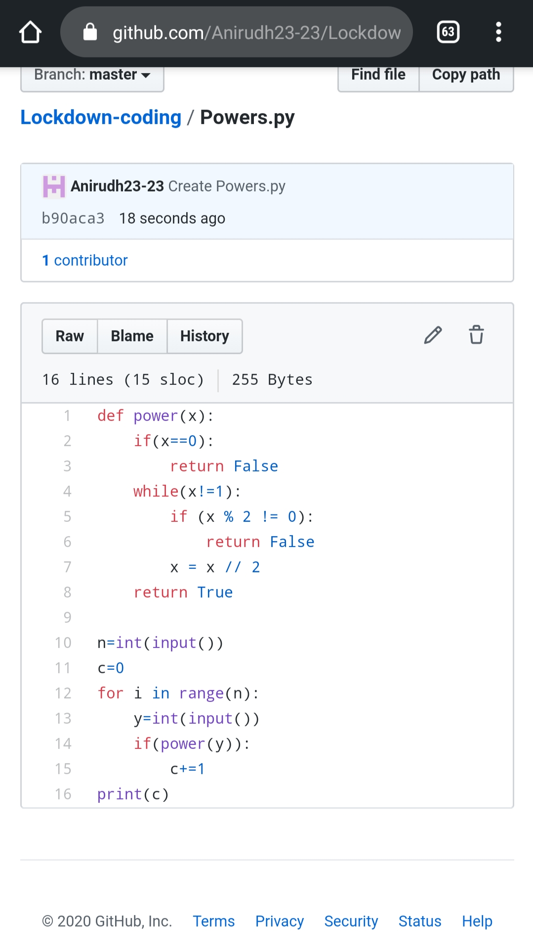

Problem 2: (using Python)You are given an array of n numbers and q queries. For each query you have to print the floor of the expected value(mean) of the subarray from L to R.

